“Supplementary data”

Antimicrobial activity of certain natural-based plant oils against the antibiotic-resistantacne bacteria
Ahmed Esmael^{a,b,1}, Mervat G. Hassan^{b,1}, Mahmoud M. Amer^{b}, Soheir Abdelrahman^{c}, Ahmed M. Hamed^{d}, Hagar A. Abd-raboh^{b}, Mohamed F. Foda^{a,e,⁎}
ªState Key Laboratory of Agricultural Microbiology, College of Plant Science and Technology, College of Life
Science and Technology, College of Science, Huazhong Agricultural University, Wuhan 430070, China
^{b} Botany and Microbiology Department, Faculty of Science, Benha University, Qalubiya Governorate 13511, Egypt
c Clinical Pathology Department, Faculty of Medicine, Benha University, Qalubiya Governorate 13511, Egypt
^{d} Dermatology Department, Faculty of Medicine, Benha University, Qalubiya Governorate 13511, Egypt
^{e} Department of Biochemistry, Faculty of Agriculture, Benha University, Moshtohor, Toukh 13736, Egypt

*Correspondence: Mohamed F. Foda, Email address: m.frahat@fagr.bu.edu.eg
¹ These two authors contributed equally to this manuscript.

Author Contributions: A.E., M.G.H., M.M.A., S.A., A.M.H. and M.F.F designed research; A.E., M.G.H. and H.A.A performed the experiments; A.E., M.G.H., and M.F.F. assembled the 16S rRNA sequences; M.F.F. project administration; M.F.F. funding acquisition; A.E., M.G.H., M.M.A., S.A., A.M.H. and M.F.F. analyzed data; A.E., M.G.H and M.F.F wrote the paper. All authors listed have made a direct, substantial and intellectual contribution to this work therefore approved it for publication.

Sup Table S1. Biochemical characterization of the acne bacteria isolated from Benha University Hospital, Egypt.
Isolates | Morphological characteristics and Biochemical tests |  |  |  |  |  |  |  |  |  |  |  |  | Designated name based on 16S rRNA sequencing | NCBI accession number
 | Morphology  & Arrange | Motility | Gram stain | blood hemolysis | Oxidase | Catalase | Gelatinase | Coagulase | DNase | Indole | Nitrate | Mannitol | glucose
Aerobic isolate #1 | Coccus in clusters | - | + | Beta hemolysis | - | + | + | + | + | - | + | + | + ª | Staph. aureus  strain EG-AE1 | MK934843
Aerobic isolate #2 | Coccus in clusters | - | + | Gamma hemolysis | - | + | - | - | - | - | + | - | + ª | Staph. epidermidis strain EG-AE2 | MK937638
Anaerobic isolate | Pleomorphic Bacilli | - | + | Weak or no hemolysis | NA | + | + | NA | - | + | + | + | +ª | Cutibacterium acnes Strain EG-AE1 | MN336167
ª denotes for Glucose fermentation with gas production, not tested (NA)
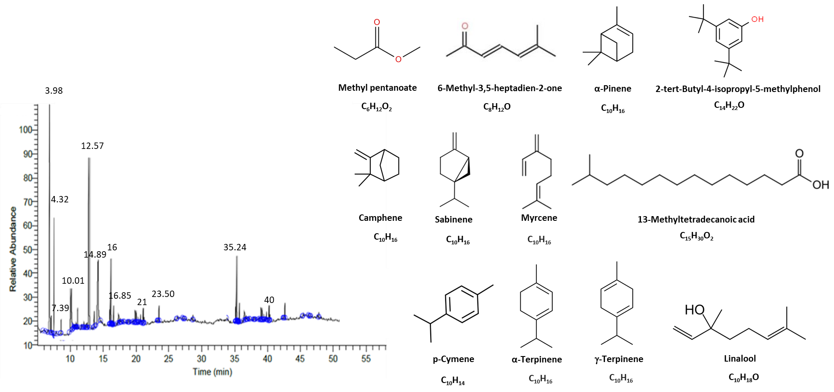
a
b

Sup. Figure 1. Gas chromatogram of the ethanolic extract of the tea tree oil resin. a) The GC-MS chromatogram. b) The chemical structure of the oil major constituents.

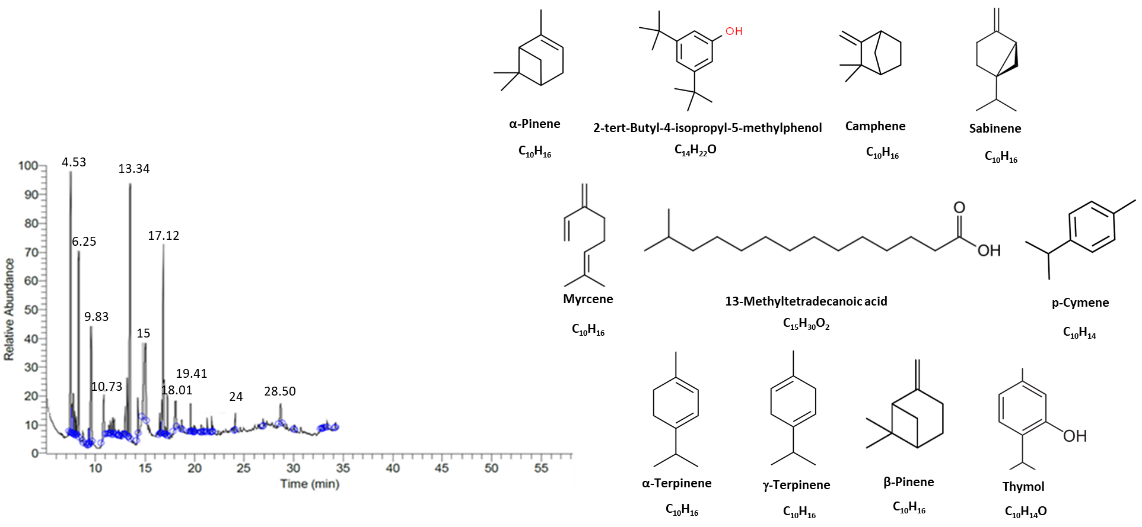
a
b

Sup. Figure 2. Gas chromatogram of the ethanolic extract of Rosemary oil resin. a) The GC-MS chromatogram. b) The chemical structure of the oil major constituents

